Suggested Solution of Assignment 4
Problem A.
A random variable of the F-distribution with df1 and df2 can be written as the ratio of scaled chi-square: $=\frac{U_{1}/df1}{U_{2}/df2}$ ,
where $U_{1}$ and $U_{2}$ are chi-square distributions with df1 and df2 degrees of freedom respectively. And the chi-square distribution with k degrees freedom is the distribution of a sum of the squares of k independent standard normal random variables.

n=100000
d1=2
d2=3
fsample=rep(0,n)
for(i in 1:n){
nor1=rnorm(d1)
sum1=sum(nor1^2)
nor2=rnorm(d2)
sum2=sum(nor2^2)
fsample[i]=(sum1/d1)/(sum2/d2)
}
#hist(fsample, freq=FALSE,main= "F distribution sampling ")
#t=seq(0,max(fsample),0.1)
#lines(t,df(t,d1,d2))
hist(fsample, n=1000,freq=FALSE,main= "F distribution sampling ",xlim=c(0,100))
t=seq(0,max(fsample),1)
lines(t,df(t,d1,d2),col=2)
summary(fsample)
sd(fsample)

> summary(fsample)
Min. 1st Qu. Median Mean 3rd Qu. Max.
0.000 0.318 0.880 3.060 2.272 6311.000
> sd(fsample)
[1] 34.41248

Problem B.
Problem B1:
#method1: use uniform distribution
estimate=rep(0,10)
for (i in 1:10){
u=runif(1000)
scaled=4*u #then scaled follows uniform(0,4)
estimate[i]=4*mean(exp(-scaled^2))
}
summary(estimate)
sd(estimate)

> estimate
[1] 0.8882798 0.8623377 0.8443195 0.9230899 0.8564120 0.8462118 0.8670758
[8] 0.9408909 0.8694783 0.9230283
> summary(estimate)
Min. 1st Qu. Median Mean 3rd Qu. Max.
0.8443 0.8579 0.8683 0.8821 0.9143 0.9409
> sd(estimate)
[1] 0.03496132

#method2: Exact Method
$$\int_{0}^{4}{e^{-x^{2}}dx}=\int_{0}^{4}{\left\{\sqrt{2π}\frac{1}{\sqrt{2}}\left[Φ\left(\frac{4-0}{\frac{1}{\sqrt{2}}}\right)-Φ(\frac{0-0}{\frac{1}{\sqrt{2}}})\right]\right\} \left\{\frac{\frac{1}{\sqrt{2π}\frac{1}{\sqrt{2}}}e^{-\frac{{(x-0)}^{2}}{2*{(\frac{1}{\sqrt{2}})}^{2}}}}{Φ\left(\frac{4-0}{\frac{1}{\sqrt{2}}}\right)-Φ(\frac{0-0}{\frac{1}{\sqrt{2}}})}\right\}dx}$$

p(x)=$\frac{\frac{1}{\sqrt{2π}\frac{1}{\sqrt{2}}}e^{-\frac{{(x-0)}^{2}}{2*{(\frac{1}{\sqrt{2}})}^{2}}}}{Φ\left(\frac{4-0}{\frac{1}{\sqrt{2}}}\right)-Φ(\frac{0-0}{\frac{1}{\sqrt{2}}})}$ is the density of the truncated normal, satisfying $\int_{0}^{4}{p(x)dx=1}$. The corresponding f(x)=$\sqrt{2π}\frac{1}{\sqrt{2}}\left[Φ\left(\frac{4-0}{\frac{1}{\sqrt{2}}}\right)-Φ(\frac{0-0}{\frac{1}{\sqrt{2}}})\right]$, which is actually a constant c

so, $\int_{0}^{4}{e^{-x^{2}}dx}=\int_{0}^{4}{f\left(x\right)*p(x)dx}$ = c

so, we actually do not need to perform the sampling. The integral is equal to c:
pnorm((4-0)/ 0.5^0.5)-0.5)*(2*pi)^0.5*0.5^0.5
which is 0.8862269.
The most beautiful thing is: this is the exact answer, without Monte Carlo error

Problem B2:
estimate=rep(0,10)
for (i in 1:10){
u=runif(1000)
scaled=pi*u #then scaled follows uniform(0,pi)
estimate[i]=pi*mean(sin(scaled))
}
summary(estimate)
sd(estimate)

> estimate
[1] 1.989799 1.960331 1.970383 1.976609 2.018206 1.986528 1.986742 2.041883
[9] 2.031602 2.017349
> summary(estimate)
Min. 1st Qu. Median Mean 3rd Qu. Max.
1.960 1.979 1.988 1.998 2.018 2.042
> sd(estimate)
[1] 0.0274921

Problem C．
R code for MH algorithm using U(0, π) as proposal density (the first 50000 samples is consider as “burn in” and the next 50000 samples is used to calculate the statistics):

n <- 100000
theta0 <- runif(1,0,pi)
theta <- c(theta0,rep(0,n))
u <- runif(n)
for (i in 1:n){
cand <- runif(1,0,pi) # candidate sampled from U(0,pi)
r <- sin(cand)/sin(theta[i])
if (u[i]<min(r,1))
theta[i+1] <- cand
else
theta[i+1] <- theta[i]
}
hist(theta[50001:n],freq=F,xlab="x",main="Density of Csin(x)") # plotting the sample density
lines(x<-seq(0,pi,0.01),y<-sin(x)/2,type="l",col="red") # plotting the actual density
win.graph()
acf(theta[50001:n]) # the ACF of the samples

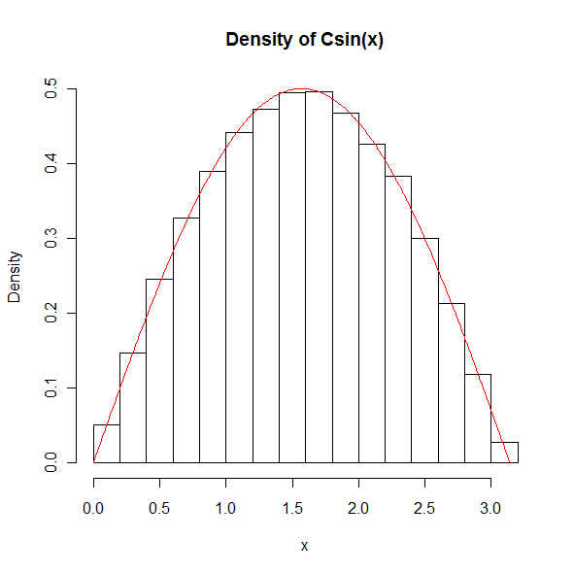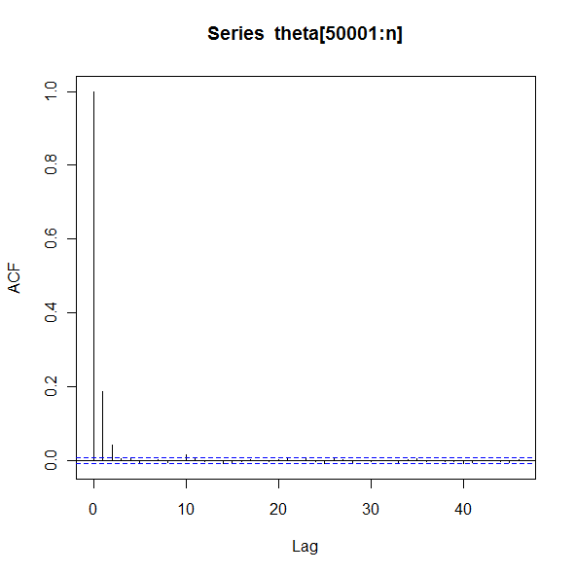

Summary statistics:
mean(theta[50001:n])
var(theta[50001:n])
 | Mean | Variance
X | 1.570993 | 0.4710704

#method1: Gibbs Sampling
The conditional distributions $p\left(x | y\right)=N(-\frac{y}{2},\frac{1}{2})$ and $p\left(y | x\right)=N(-\frac{x}{2},\frac{1}{2})$, then Gibbs Sampling can be used.

n <- 100000
theta0 <- c(rnorm(1),rnorm(1))
theta <- matrix(c(theta0,rep(0,n*2)),nc=2,byrow=T)
for (i in 1:n){
theta[i+1,1]=rnorm(1,mean=-0.5*theta[i,2],sd=sqrt(0.5))
theta[i+1,2]=rnorm(1,mean=-0.5*theta[i+1,1],sd=sqrt(0.5))
}
plot(theta[50001:n,],xlab="x",ylab="y",main="Density of Cexp{-(x^2+x*y+y^2)}")
fxy1<- function(x,y) {exp(-x^2-x*y-y^2)}
x <- seq(-3, 3, 0.05)
y <- x
z <- outer(x,y,fxy1)
contour(x,y,z,nlevels=10,col="red",add=T) # adding theoretical contour to the plot
win.graph()
acf(theta[50001:n,])

Summary Statistics:
mean(theta[50001:n,1])
var(theta[50001:n,1])
mean(theta[50001:n,2])
var(theta[50001:n,2])
cor(theta[50001:n,1],theta[50001:n,2])

 | Mean | Variance
X | -0.00451189 | 0.6602126
Y | 0.005310141 | 0.6665577
Corr(X,Y) | -0.4998561

#method2: M-H Algorithm
The candidate (x*, y*) is sampled from x* ~ N(x_{t-1}, 1) and y* ~ N(y_{t-1}, 1) independently.

n <- 100000
theta0 <- c(rnorm(1),rnorm(1))
theta <- matrix(c(theta0,rep(0,n*2)),nc=2,byrow=T)
u <- runif(n)
for (i in 1:n){
cand <- c(rnorm(1,theta[i,1],1),rnorm(1,theta[i,2],1))
r <- exp(-cand[1]^2-cand[1]*cand[2]-cand[2]^2+theta[i,1]^2+theta[i,1]*theta[i,2]+theta[i,2]^2)
if (u[i]<min(r,1))
theta[i+1,] <- cand
else
theta[i+1,] <- theta[i,]
}
plot(theta[50001:n,],xlab="x",ylab="y",main="Density of Cexp{-(x^2+x*y+y^2)}")
fxy1<- function(x,y) {exp(-x^2-x*y-y^2)}
x <- seq(-3, 3, 0.05)
y <- x
z <- outer(x,y,fxy1)
contour(x,y,z,nlevels=10,col="red",add=T) # adding theoretical contour to the plot
win.graph()
acf(theta[50001:n,])

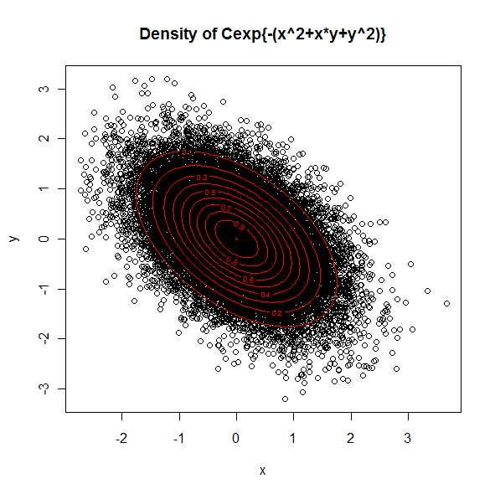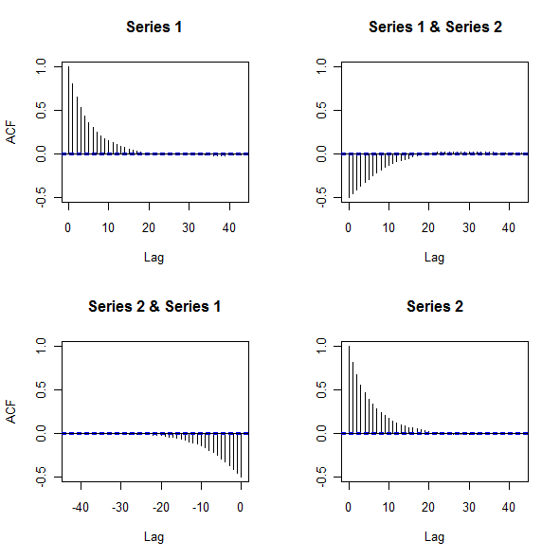
Summary Statistics:
mean(theta[50001:n,1])
var(theta[50001:n,1])
mean(theta[50001:n,2])
var(theta[50001:n,2])
cor(theta[50001:n,1],theta[50001:n,2])

 | Mean | Variance
X | 0.002310484 | 0.6523074
Y | 0.01706224 | 0.6714803
Corr(X,Y) | -0.4988285

#method1: Combine Gibbs Sampling and M-H Algorithm
The conditional distribution $p\left(y | x\right)=N(-\frac{x}{2},\frac{1}{2})$, hence Gibbs sampling can be used to sample y. M-H Algorithm is used to sample x and the candidate x* is sampled from x* ~ LN(x_{t-1}, 2).

n <- 100000
theta0 <- c(rlnorm(1),rnorm(1))
theta <- matrix(c(theta0,rep(0,n*2)),nc=2,byrow=T)
u <- runif(n)
for (i in 1:n){
cand <- rlnorm(1,theta[i,1],2)
r <- exp(-cand^3-cand*theta[i,2]+theta[i,1]^3+theta[i,1]*theta[i,2])*dlnorm(theta[i,1],cand,2)/dlnorm(cand,theta[i,1],2)
if (u[i]<min(r,1))
theta[i+1,1] <- cand
else
theta[i+1,1] <- theta[i,1]
theta[i+1,2]<-rnorm(1,-0.5*theta[i+1,1],sqrt(0.5))
}
plot(theta[50001:n,],xlab="x",ylab="y",main="Density of Cexp{-(x^3+x*y+y^2)}")
fxy2<- function(x,y) {exp(-x^3-x*y-y^2)}
x <- seq(0, 3, 0.05)
y <- x
z <- outer(x,y,fxy2)
contour(x,y,z,nlevels=10,col="red",add=T)
y <- seq(-3, 0, 0.05)
z <- outer(x,y,fxy2)
contour(x,y,z,nlevels=10,col="red",add=T)
win.graph()
acf(theta[50001:n,])

Summary statistics:
mean(theta[50001:n,1])
var(theta[50001:n,1])
mean(theta[50001:n,2])
var(theta[50001:n,2])
cor(theta[50001:n,1],theta[50001:n,2])

 | Mean | Variance
X | 0.5410762 | 0.1313421
Y | -0.2693923 | 0.5300515
Corr(X,Y) | -0.2384271

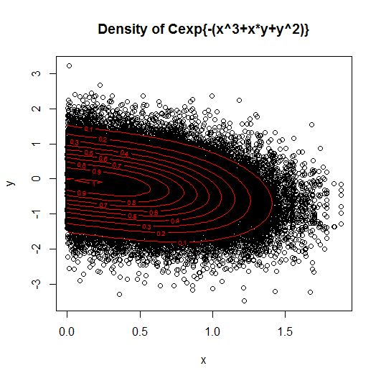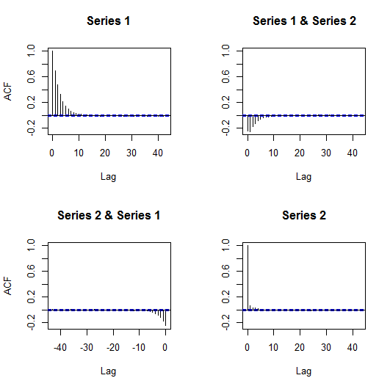

#method2: M-H Algorithm
The candidate (x*, y*) is sampled from x* ~ LN(x_{t-1}, 2) and y* ~ N(y_{t-1}, 1) independently.

n <- 100000
theta0 <- c(rlnorm(1),rnorm(1))
theta <- matrix(c(theta0,rep(0,n*2)),nc=2,byrow=T)
u <- runif(n)
for (i in 1:n){
cand <- c(rlnorm(1,theta[i,1],2),rnorm(1,theta[i,2],1))
r <- exp(-cand[1]^3-cand[1]*cand[2]-cand[2]^2+theta[i,1]^3+theta[i,1]*theta[i,2]+theta[i,2]^2)*dlnorm(theta[i,1],cand[1],2)/dlnorm(cand[1],theta[i,1],2)
if (u[i]<min(r,1))
theta[i+1,] <- cand
else
theta[i+1,] <- theta[i,]
}
plot(theta[50001:n,],xlab="x",ylab="y",main="Density of Cexp{-(x^3+x*y+y^2)}")
fxy2<- function(x,y) {exp(-x^3-x*y-y^2)}
x <- seq(0, 3, 0.05)
y <- x
z <- outer(x,y,fxy2)
contour(x,y,z,nlevels=10,col="red",add=T)
y <- seq(-3, 0, 0.05)
z <- outer(x,y,fxy2)
contour(x,y,z,nlevels=10,col="red",add=T)
win.graph()
acf(theta[50001:n,])

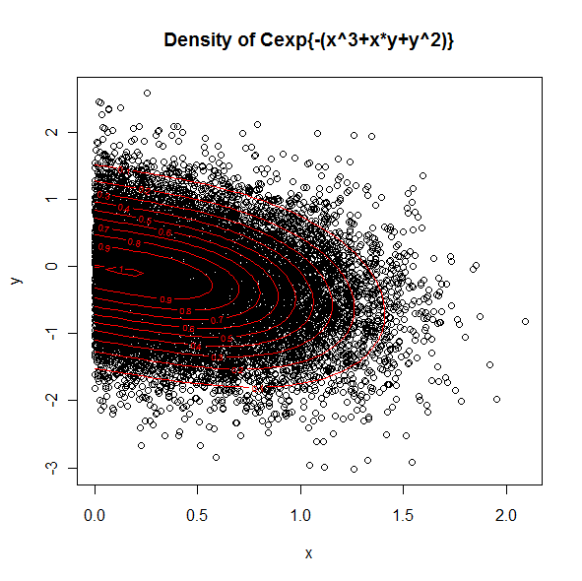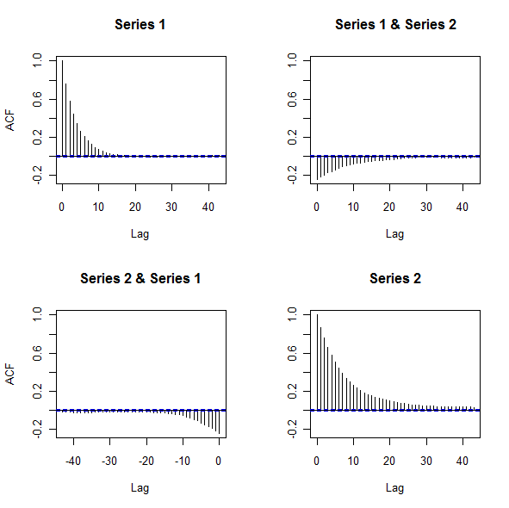

Summary statistics:
mean(theta[50001:n,1])
var(theta[50001:n,1])
mean(theta[50001:n,2])
var(theta[50001:n,2])
cor(theta[50001:n,1],theta[50001:n,2])

 | Mean | Variance
X | 0.5376759 | 0.133126
Y | -0.2699721 | 0.5472689
Corr(X,Y) | -0.2384271
The candidate (x*, y*) is sampled from x* ~ LN(x_{t-1}, 2) and y* ~ LN(y_{t-1}, 2) independently.

n <- 100000
theta0 <- c(rlnorm(1),rlnorm(1))
theta <- matrix(c(theta0,rep(0,n*2)),nc=2,byrow=T)
u <- runif(n)
for (i in 1:n){
cand <- c(rlnorm(1,theta[i,1],2),rlnorm(1,theta[i,2],2))
r <- exp(-cand[1]^3-cand[1]*cand[2]-cand[2]^2+theta[i,1]^3+theta[i,1]*theta[i,2]+theta[i,2]^2)*dlnorm(theta[i,1],cand[1],2)*dlnorm(theta[i,2],cand[2],2)/(dlnorm(cand[1],theta[i,1],2)*dlnorm(cand[2],theta[i,2],2))
if (u[i]<min(r,1))
theta[i+1,] <- cand
else
theta[i+1,] <- theta[i,]
}
plot(theta[50001:n,],xlab="x",ylab="y",main="Density of Cexp{-(x^3+x*y+y^3)}")
fxy3<- function(x,y) {exp(-x^3-x*y-y^3)}
x <- seq(0, 3, 0.05)
y <- x
z <- outer(x,y,fxy3)
contour(x,y,z,nlevels=10,col="red",add=T)
win.graph()
acf(theta[50001:n,])
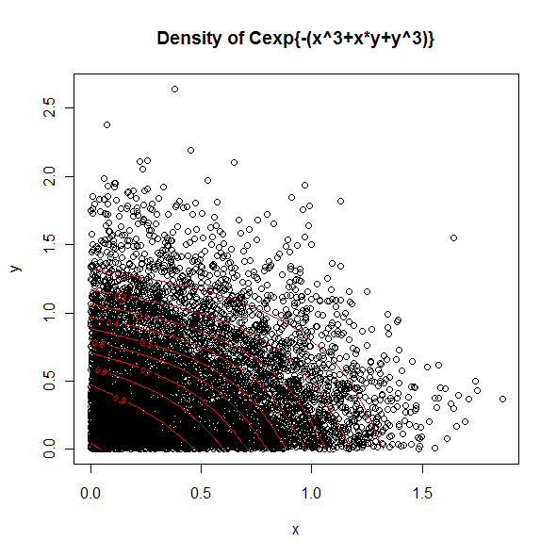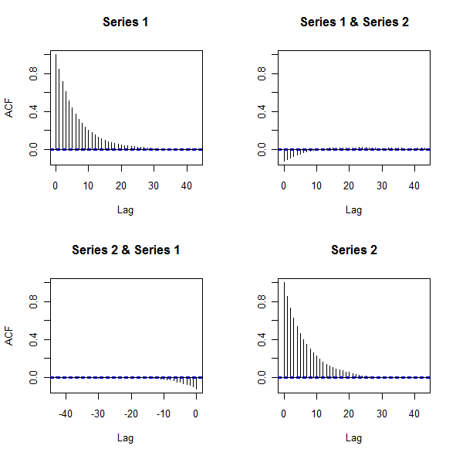
Summary statistics:
mean(theta[50001:n,1])
var(theta[50001:n,1])
mean(theta[50001:n,2])
var(theta[50001:n,2])
cor(theta[50001:n,1],theta[50001:n,2])

 | Mean | Variance
X | 0.4567664 | 0.1039308
Y | 0.4834651 | 0.1474323
Corr(X,Y) | -0.1218784

